**Practice-1**

**Aim:Write a C Program to print the below design using printf function with help of \t & \n escape sequence(please check below the image in attachment section).**

**Promgram:**

#include<stdio.h>

#include<conio.h>

#define p printf

main()

{

clrscr();

p(" * * \n");

p(" * * \n");

p("* * \n");

p(" * * \n");

p(" * * \n");

getch();

}

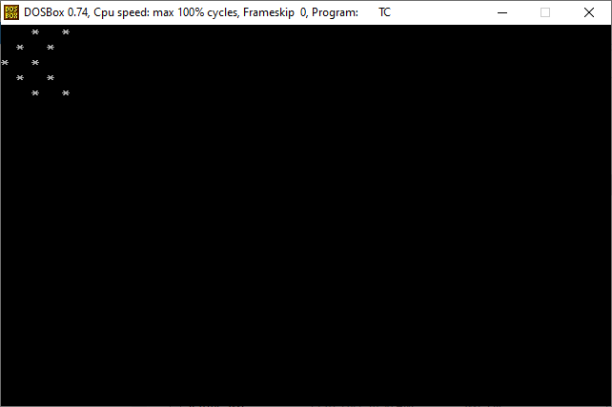

**Output:**

**Practice-1**

**Aim:Write a C Program to print the below design using printf function with help of \t & \n escape sequence(please check below the image in attachment section).**

**Promgram:**

#include<stdio.h>

#include<conio.h>

#define p printf

main()

{

clrscr();

p(" * * * * * * *\n");

p("* * *\n");

p("* * * * * *\n");

p("* * * * *\n");

p("* * * * *\n");

p("* * * * * * * *\n");

getch();

}

**Output:**

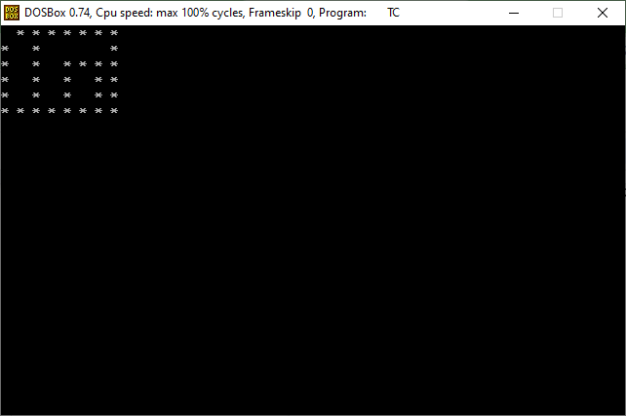

**Practice-2**

**Aim:** Write a C Program to perform a swapping of two variables.

**Promgram:**

#include<stdio.h>

#include<conio.h>

#define p printf

#define s scanf

main()

{

int a,b,t=0;

clrscr();

p("enter value of a::");

s("%d",&a);

p("enter value of b::");

s("%d",&b);

p("after swapping::\n\n");

t=a;

a=b;

b=t;

p("a=%d\nb=%d",a,b);

getch();

}

**Output:**

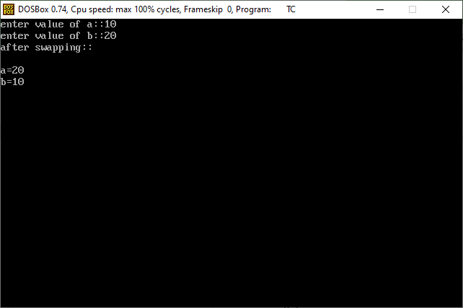

**Practice-3**

**Aim:Write a C program to convert temperature from degree Celsius to Fahrenheit.**

**Promgram:**

#include<stdio.h>

#include<conio.h>

#define p printf

#define s scanf

main()

{

clrscr();

int c;

float f;

p("enter celcius::");

s("%d",&c);

f=c*1.8+32;

p("fahrenheit=%.2f",f);

getch();

}

**Output:**

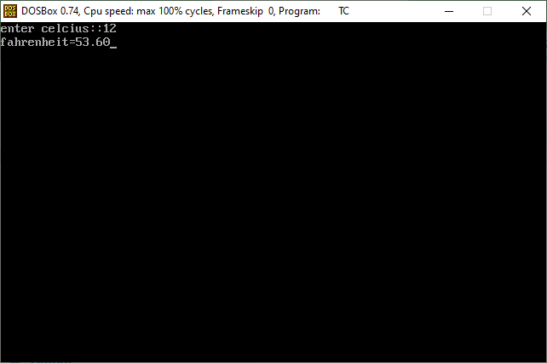

**Practice-4**

**Aim:Write C Program to find gross salary.**

**Ex. Base Salary: 100 RS, HRA=10%, DA=5%, TA=8%.**

**Ans = 123 RS**

**Promgram:**

#include<stdio.h>

#include<conio.h>

#define p printf

#define s scanf

main()

{

int salary,hra,da,tax,total;

clrscr();

p("enter salary::");

s("%d",&salary);

hra=salary*10/100;

p("hra=%d\n",hra);

da=salary*5/100;

p("da=%d\n",da);

tax=salary*8/100;

p("tax=%d\n",tax);

total=salary+hra+da+tax;

p("total=%d\n",total);

getch();

}

**Output:**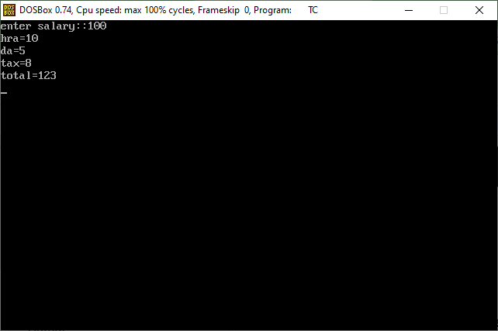

**Practice-5**

**Aim:Write a C Program to convert kilometer in miles and vise verse based on user input.**

**Promgram:**

#include<stdio.h>

#include<conio.h>

#define p printf

#define s scanf

main()

{

int kilometer;

float miles;

clrscr();

p("enter kilometer::");

s("%d",&kilometer);

miles=kilometer*0.62;

p("miles=%.2f",miles);

getch();

}

**Output:**

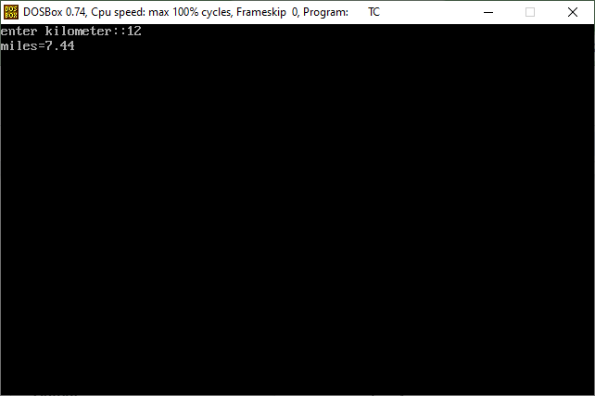

**Practice-6**

**Aim: Write a C program that calculates the volume of a sphere.**

**Promgram:**

#include<stdio.h>

#include<conio.h>

#define p printf

#define s scanf

main()

{

clrscr();

float pi=3.14,r,v;

p("enter radius::");

s("%f",&r);

v=4/3*pi*r*r*r;

p("volume of sphere=%f",v);

getch();

}

**Output:**

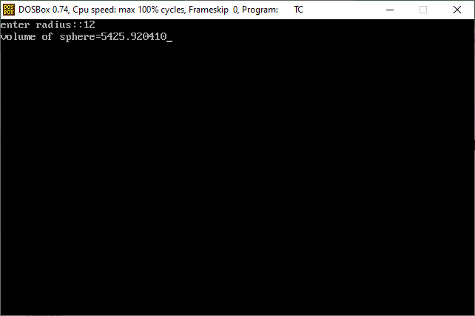

**Practice-7**

**Aim: Write a C program that takes hours and minutes as input, and calculates the total number of minutes.**

**Promgram:**

#include<stdio.h>

#include<conio.h>

#define p printf

#define s scanf

main()

{

int hours,m,minutes,total;

clrscr();

p("enter your hours::");

s("%d",&hours);

m=hours*60;

printf("enter your minutes::");

s("%d",&minutes);

total=m+minutes;

p("total minutes=%d",total);

getch();

}

**Output:**

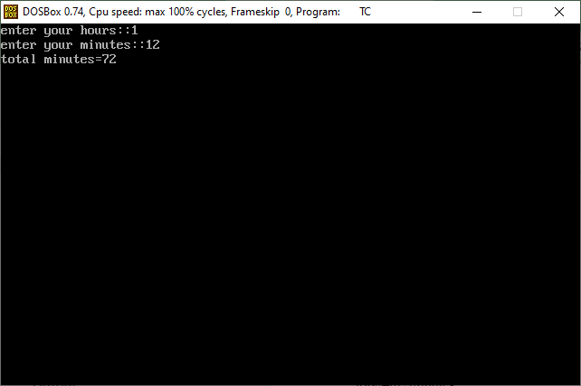

**Practice-8**

**Aim: Write a C program to find the third angle of a triangle if two angles are given.**

**Expected Output:**

**Input two angles of triangle separated by comma : 50, 70**

**Third angle of the triangle : 60**

**Promgram:**

#include<stdio.h>

#include<conio.h>

#define p printf

#define s scanf

main()

{

clrscr();

int a,b,c;

p("enter first angle::");

s("%d",&a);

p("enter second angle::");

s("%d",&b);

c=180-(a+b);

p("third angle = %d",c);

getch();

}

**Output:**

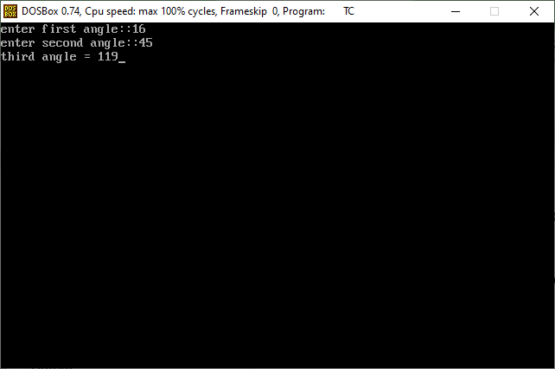

**Practice-9**

**Aim: Write a C program to find velocity of given speed and time.**

**Promgram:**

#include<stdio.h>

#include<conio.h>

#define p printf

#define s scanf

main()

{

int d,t,v;

clrscr();

p("enter distance::");

s("%d",&d);

p("enter time::");

s("%d",&t);

v=d/t;

p("velocity of time=%d",v);

getch();

}

**Output:**